# TABLE OF CONTENTS

Contents

TABLE OF CONTENTS 1

INTRODUCTION 2

Purpose of report 2

Brief history of electric motors 2

HYSTERISIS MOTOR 2

Motor construction (Rotor and stator) 2

Motor performance 3

Torque-speed characteristics 3

Motor field windings 3

Applications 4

UNIVERSAL MOTOR 4

Motor construction (Rotor and stator) 4

Motor performance 4

Torque-speed characteristics 5

Motor field windings 5

Applications 5

COMPARISON OF UNIVERSAL AND HYSTERISIS MOTORS 5

Advantages and disadvantages of each motor type 5

Key differences in motor construction and performance 6

CONCLUSION 6

Summary of findings 6

Implications for future research and development 6

TABLE OF FIGURES 7

REFERENCES 7

# INTRODUCTION

## Purpose of report

Electric motors are ubiquitous in modern life, powering devices ranging from small household appliances to large industrial machinery. Understanding the principles of motor operation, performance, and construction is essential for engineers and scientists working in a wide range of fields, from electrical and mechanical engineering to materials science and physics. In this report, we will discuss two types of electric motors: hysteresis motors and universal motors.

The purpose of this report is to provide a comprehensive overview of hysteresis motors and universal motors, including their construction, performance, and applications. We will compare and contrast the two motor types, highlighting their unique strengths and limitations. By the end of this report, readers will have a deeper understanding of electric motor technology and its practical applications.

## Brief history of electric motors

Electric motors have a rich history dating back to the early 19th century, when scientists and inventors began exploring the principles of electromagnetism. In 1821, Michael Faraday discovered the principle of electromagnetic induction, which laid the foundation for the development of electric motors. In the following decades, inventors such as Thomas Davenport and Robert Davidson developed primitive electric motors, which were used primarily for scientific demonstrations and toys.

The first practical electric motor was developed by Werner von Siemens in 1860, using a commutator to convert alternating current (AC) to direct current (DC) and vice versa. This invention paved the way for the development of more efficient and powerful electric motors, which played a crucial role in the industrial revolution. Today, electric motors are used in a wide range of applications, from electric vehicles to wind turbines.

# HYSTERISIS MOTOR

## Motor construction (Rotor and stator)

The hysteresis motor is a synchronous motor that operates on the principle of hysteresis, which refers to the tendency of a magnetic material to retain its magnetic state even after the magnetic field has been removed. The construction of a hysteresis motor typically includes a rotor made of a magnetic material with high coercive force, such as cobalt steel or chromium steel, and a stator with a series of evenly spaced windings. The rotor is typically a smooth cylinder or disk with an axially oriented magnetic field, while the stator is a cylindrical structure with multiple poles.

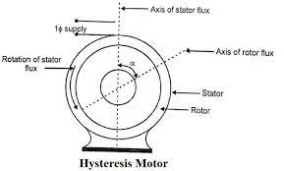

Figure Figure

## Motor performance

The performance of a hysteresis motor is characterized by high efficiency, high torque, and low noise. Because the rotor is made of a magnetic material with high coercive force, it has a high degree of magnetic hysteresis, which allows it to maintain a constant magnetic field even when the magnetic field of the stator changes rapidly. This results in a smooth and stable rotation of the rotor, with minimal electrical noise and vibration.

## Torque-speed characteristics

The torque-speed characteristics of a hysteresis motor are relatively constant over a wide range of speeds, making it ideal for applications that require precise and stable speed control. The torque produced by a hysteresis motor is proportional to the strength of the magnetic field, and the speed is inversely proportional to the number of poles in the stator. This means that hysteresis motors with a higher number of poles have a lower speed but a higher torque, while those with a lower number of poles have a higher speed but a lower torque.

## Motor field windings

The stator of a hysteresis motor typically contains two types of windings: a main winding and an auxiliary winding. The main winding is used to provide the magnetic field that interacts with the rotor, while the auxiliary winding is used to provide a starting torque to the rotor. The auxiliary winding is typically connected to a capacitor to create a phase shift between the currents in the two windings, which helps to create a rotating magnetic field.

Figure

## Applications

Hysteresis motors are used in a wide range of applications where precise and stable speed control is required, such as in clocks, timers, and other precision instruments. They are also used in fans, pumps, and other industrial equipment where low noise and high efficiency are important. Because of their simple construction and low maintenance requirements, hysteresis motors are often preferred over other types of motors in applications where reliability is critical.

# UNIVERSAL MOTOR

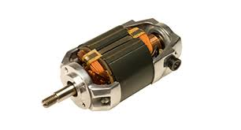

## Motor construction (Rotor and stator)

The universal motor is a type of electric motor that is designed to operate on both AC and DC power. It is similar in construction to a DC motor, with a rotor and stator, but it also includes a commutator and brushes to convert AC power to DC power. The rotor of a universal motor is typically made of laminated steel with copper windings, while the stator is made of iron with multiple poles.

## Motor performance

The performance of a universal motor is characterized by high speed, high torque, and low cost. Because it can operate on both AC and DC power, it is a versatile motor that can be used in a wide range of applications. However, it is less efficient than other types of motors, and it produces a significant amount of electrical noise and vibration.

## Torque-speed characteristics

The torque-speed characteristics of a universal motor are similar to those of a DC motor, with a high starting torque and a relatively constant torque over a wide range of speeds. The speed of a universal motor is proportional to the voltage applied to the motor, and the torque is proportional to the current flowing through the motor.

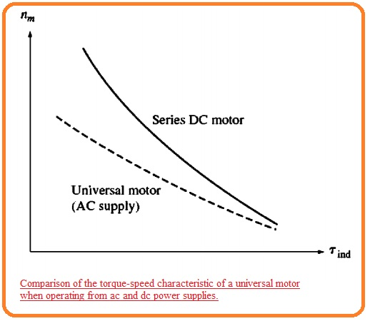

Figure

## Motor field windings

The stator of a universal motor typically contains two windings: a main winding and a compensating winding. The main winding is used to provide the magnetic field that interacts with the rotor, while the compensating winding is used to reduce the effects of armature reaction and improve the motor's performance on AC power.

## Applications

Universal motors are widely used in applications where high speed and high torque are required, such as in power tools, vacuum cleaners, and other portable appliances. They are also used in industrial applications where cost is a primary consideration, such as in small fans and pumps. However, because of their high noise and vibration levels, they are not suitable for applications where low noise is important.

# COMPARISON OF UNIVERSAL AND HYSTERISIS MOTORS

## Advantages and disadvantages of each motor type

|  |  |  |
| --- | --- | --- |
|  | Advantages | Disadvantages |
| 1. Hysteresis Motor | high efficiency, high torque, low noise, and stable speed; | low speed, high cost, and limited applications. |
| 2. Universal Motor | high speed, high torque, low cost, and versatile power supply; | low efficiency, high noise, and limited applications. |

## Key differences in motor construction and performance

|  |  |  |
| --- | --- | --- |
|  | 1. Hysteresis Motor | 2. Universal Motor |
| MOTOR CONSTRUCTION | synchronous motors with a rotor made of a magnetic material and a stator with windings; | versatile motors with a rotor, stator, commutator, and brushes |
| Motor Performance | relatively constant torque over a wide range of speeds, ideal for precise and stable speed control; | high starting torque and relatively constant torque over a wide range of speeds, ideal for high speed and high torque applications. |
| Motor Field Windings | typically contain a main winding and an auxiliary winding; | typically contain a main winding and a compensating winding. |
| Applications | used in clocks, timers, and other precision instruments, as well as in fans and pumps where low noise and high efficiency are important. | used in power tools, vacuum cleaners, and other portable appliances where high speed and high torque are required. |

# CONCLUSION

## Summary of findings

In summary, hysteresis motors and universal motors are two different types of electric motors with distinct advantages and disadvantages. Hysteresis motors offer high efficiency, high torque, and low noise, making them ideal for applications that require precise and stable speed control. Universal motors offer high speed, high torque, and low cost, making them ideal for applications that require high speed and high torque. The torque-speed characteristics of hysteresis motors and universal motors are also distinct, with hysteresis motors having relatively constant torque over a wide range of speeds and universal motors having high starting torque and relatively constant torque over a wide range of speeds.

## Implications for future research and development

The comparison between hysteresis motors and universal motors highlights the importance of designing electric motors with specific performance characteristics to meet the needs of different applications. Future research and development in electric motor technology should focus on improving the efficiency and reducing the noise and vibration of hysteresis motors, as well as expanding the range of applications for these motors. For universal motors, future research should focus on improving the efficiency of these motors, while still maintaining their low cost and high speed capabilities. Additionally, future research could explore the potential for hybrid motor designs that combine the advantages of hysteresis and universal motors.

Overall, the comparison between hysteresis motors and universal motors demonstrates the importance of understanding the unique characteristics of different types of electric motors and their suitability for different applications. By continuing to improve the performance and efficiency of electric motors, researchers and engineers can contribute to a more sustainable and energy-efficient future.

# TABLE OF FIGURES

Figure 1 Figure 2 3

Figure 3 4

Figure 4 5

# REFERENCES

A Brief History of Electric Motors. (n.d.). *Electrical Apparatus Magazine*. Retrieved from https://electricalapparatus.wordpress.com/2018/08/17/a-brief-history-of-electric-motors/

A E FitzGerald, C Kingsley Jr & S D Umans. (2003). *Electric Machinery .* New York, NY: McGraw-Hill.

Bose, B. K. (2006). *Modern Power Electronics and AC Drives.* New Jersey: Pearson Education.

Faraday, M. (1821). *Experimental Researches in Electricity.* London, UK: Richard and John E. Taylor.

*Hysteresis Motor*. (n.d.). Retrieved from Electrical4U: https://www.electrical4u.com/hysteresis-motor/

Rosenblatt, F. (2003). A Short History of the Electric Motors. *Proceedings of the IEEE*, pp. 822-832.

*Universal Motor*. (n.d.). Retrieved from Electrical4U: https://www.electrical4u.com/universal-motor/